USER GUIDE

UPdate Workers

September 2018

Version 1.02

Pharmacon ITC303/309 Group

Document Revisions

|  |  |  |
| --- | --- | --- |
| Date | Version Number | Document Changes |
| 31/08/2018 | 1.01 | Draft |
| 15/09/2018 | 1.02 | Initial |
|  |  |  |
|  |  |  |
|  |  |  |
|  |  |  |
|  |  |  |
|  |  |  |
|  |  |  |

Table of Contents

1 Introduction 4

1.1 Scope and Purpose 4

1.2 Process Overview 4

2 Update Workers 5

2.1 Locate Worker Record 5

2.1.1 Upload Worker record to Worker Details Form 5

2.2 Update Worker Details 5

2.2.1 Locate field needing amendment 5

2.3 Field Information 6

2.3.1 Worker’s ID Number 6

2.3.2 Is this Worker Active? 7

# Introduction

## Scope and Purpose

The purpose of this user guide is to provide instructions on how to update a worker that has loaded into the Worker Details Form through the search feature.

No other features of the Pharmacy Error Tracker (PET) application will be discussed in this user guide.

* To be able to use PET, the user will need basic knowledge of logging into an online application, completing an online form, and can use the search function of PET.
* This feature is only available to a user with administrator rights.
* This user guide will commence from the last step in User Guide – Search Workers.

NOTE: The user must have a legitimate reason for amending/updating a worker record. For example, incorrect spelling, missed adding a comment, etc.

## Process Overview

The administrator will need to log into PET using their valid username and password.

* The Welcome Page will be presented on successful login.
* The administrator will need to follow the User Guide - Search Workers to search for the required record.

# Update Workers

User must have located the required record via Search Workers.

*NOTE: All fields except the* Worker ID *in the form can be updated to correct information/fields that contain mistakes. Care needs to be taken to ensure correct information is not changed accidentally*.

## Locate Worker Record

User must have access to the application.

User must have a valid username and password with administration rights.

### Upload Worker record to Worker Details Form

1. Select the record to be amended by clicking on the  to the right of the record.

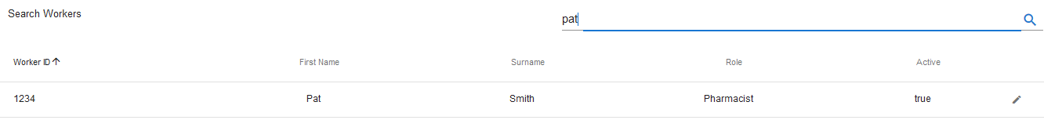

1. The record loads into the Worker Details Form

## Update Worker Details

### Locate field needing amendment

1. Locate the field containing incorrect information. Click in the field and amend the details as required. *Worker’s ID cannot be changed*   
   In the example above, the worker’s position should be Locum.

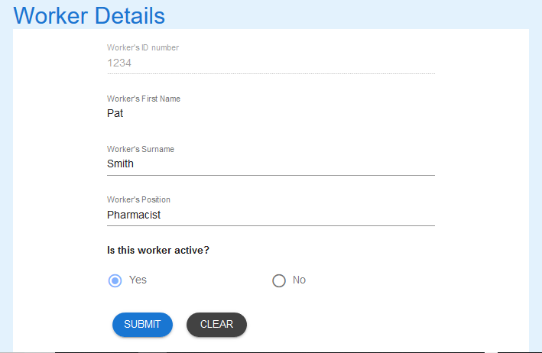

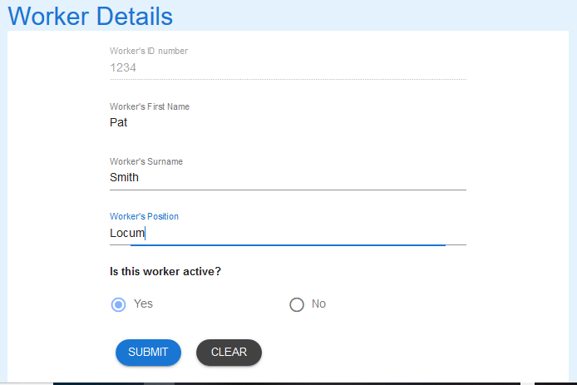

1. Select SUBMIT to update the record.



1. A successful update will receive the following message.



## Field Information

### Worker’s ID Number

1. This ID number cannot be amended once it has been entered.
2. If is incorrect, the worker will need to be made inactive and re-entered using the **“Manage Workers”** user guide.

### Is this Worker Active?

1. If the worker is no longer working for the organisation, change this field to “No”.
   1. Workers that are not active will not appear in the list of workers in the Log Error Form.
2. If an inactive worker recommences employment with the organisation, change this field to “Yes”
   1. Active workers will appear in the list of workers in the Log Error Form.

If you encounter issues not addressed by this user guide, please contact your account manager for additional support.